DR. AHMED SAEED ELSHENAWY
ORGANIZATIONAL DEVELOPMENT &
INDUSTRIAL TRANSFORMATION CONSULTANT.

Manufacturing Capability | Change Management |
Culture Transformation | L&D Strategy
Alexandria, Egypt
+20 100 624 0048
Ahmedsaidelshenawy@hotmail.com
www.linkedin.com/in/dr-ahmed-saeed-elshenawy
ORCID: https://orcid.org/0000-0002-3781-2390
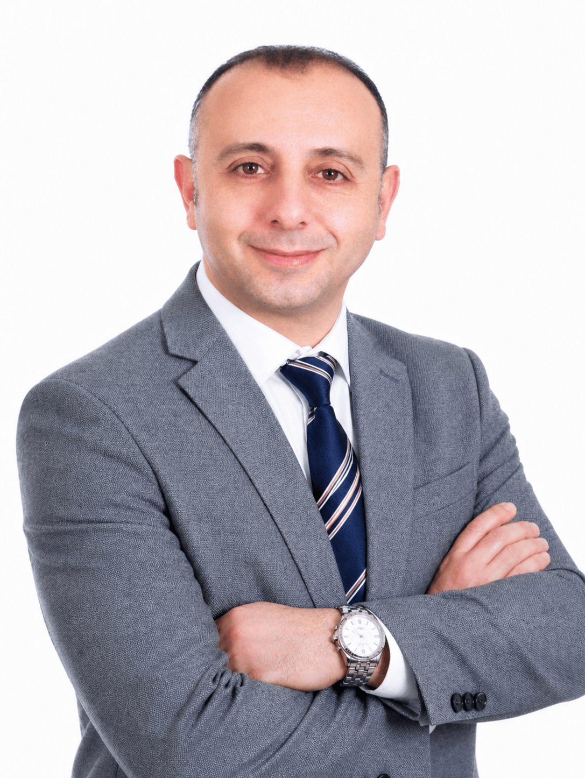
EXECUTIVE POSITIONING
- Organizational Development and transformation leader with 20+ years of experience improving institutions from an organizational lens: structure, governance, operating routines, leadership capability, stakeholder systems, performance discipline, culture, and change execution. Experienced across government, international cooperation, corporate consulting, university-sector administration, maritime training, and public-facing organizations. Strong track record translating strategic intent into practical operating models, OD roadmaps, capability-building systems, KPIs, partnership platforms, and implementation governance. The profile is positioned as an organization-development director.

- Possess high level inter-personal skills enabling effective teaching and team management leadership. I have the ability to evaluate the work of others and enable their development through consultation, coaching and support, while formulating strategies for improved learning as a result of the above.

- Proven expertise in designing and executing comprehensive OD strategies, institutional transformation roadmaps, and change management frameworks that drive measurable performance improvement. Doctorate-level practitioner in Organizational Development. Board Member of the Alexandria Growth Initiative and Founder of the Cairo Growth Initiative — committed to ecosystem-driven economic and human capital development across Egypt and the MENA region.

- Certified translator and public speaker, with broad experience across academia, government agencies, and international projects.

*Target roles: OD Manager | Industrial Transformation Director | Learning & Development Director.

INDUSTRIAL OD DIRECTOR VALUE PROPOSITION
- Translate business strategy into operating models, role clarity, workflows, decision rights, KPIs, and implementation governance.
- Lead organizational diagnosis across structure, process, people capability, culture, communication, technology adoption, and performance discipline.
- Improve manufacturing and distribution performance through workforce readiness, SOP adoption, cross-functional coordination, quality mindset, and execution routines.
- Build learning cultures that convert technical knowledge, machine adoption, customer requirements, and leadership expectations into practical capability on the ground.
- Position OD as a business-improvement function: connecting people systems with operational excellence, customer value, growth, and sustainable change.

CORE COMPETENCIES
Organization Development & Diagnosis | Operating Model Design | Role Clarity | Governance | Workflow Mapping | Stakeholder Diagnosis
Industrial Transformation | Manufacturing Capability | Technology Adoption | SOPs | Quality Mindset | Production-Commercial Alignment
Food Distribution & Commercial Operations | Procurement-to-Distribution Flow | Inventory Discipline | Route Coordination | Service Reliability | Branch Routines
Learning, Culture & Change | L&D Strategy | Manager Enablement | Knowledge Transfer | Culture Building | Change Communication

SELECTED INDUSTRIAL & COMMERCIAL OD PORTFOLIO
These engagements show Industrial Organizational Development, Capability Building & Business Improvement Portfolio

Executive Advisory / Alex Growth for Development 2026
- Designed an executive peer-advisory and organizational learning concept for owners, CEOs, and senior leaders, focused on decision quality, accountability, strategic alignment, and confidential problem-solving.
- Developed the platform logic around non-competing advisory boards, one-to-one coaching, structured facilitation, membership value proposition, and executive growth outcomes.
- Positioned the initiative as an OD-enabled leadership and business-growth ecosystem rather than a traditional training product.

El-Ahd for Food Trading & Distribution (Hala) | Egypt, 2025
- Supported organizational improvement in a food trading and distribution environment by focusing on operating routines, accountability, workflow follow-up, branch/field coordination, and service reliability.
- Reviewed the relationship between purchasing, stock availability, distribution movement, customer commitments, reporting routines, and people capability to improve the discipline of day-to-day execution.
- Promoted a culture of responsibility and operational ownership by clarifying expectations, strengthening communication loops, and encouraging practical coordination between commercial, warehouse, distribution, and administration activities.
- Contributed to performance improvement thinking around route-to-market discipline, customer service consistency, inventory awareness, supplier follow-up, and faster issue escalation.
- Used OD logic to translate operational problems into organization-level interventions: role clarity, decision flow, reporting habits, staff behavior, learning needs, and manager follow-up routines.
Impact: Positioned distribution performance as an organizational system, not only a logistics activity - linking people behavior, workflow discipline, communication, customer service, and management routines.

Comprehensive OD Transformation Plan - Ivy International | 2025
- Consulted on a school-wide organizational development plan from an institutional performance perspective, not from a teaching perspective.
- Covered organization diagnosis, structure review, role clarity, workflows, governance routines, staff capability, communication loops, performance management, and culture alignment.
- Built a phased roadmap linking academic operations, administration, leadership coordination, parent/student experience, employee engagement, and sustainable growth.
- Recommended interventions for department coordination, policy clarification, leadership routines, staff performance indicators, internal communication, and change governance.
Impact: Created a practical transformation roadmap to improve coordination, management discipline, service quality, employee capability, and institutional alignment.

Deputy CEO - Institutional Development & Career Transformation | University Center for Career Development, Alamein International University | Egypt | 2023-2025
- Led the strategic design and execution of institutional development initiatives connecting employability, employer relations, capability building, revenue generation, stakeholder value, and service quality.
- Built operating routines, staff coordination mechanisms, reporting practices, forums, stakeholder events, and employer-engagement systems to increase institutional performance and visibility.
- Managed partnerships with academic institutions, private-sector employers, vocational bodies, and business associations to expand organizational reach and service outcomes.
- Improved performance through market feedback, trainee progress tracking, trainer performance review, partnership evaluation, and service-quality refinement.
- Directed major stakeholder events including the first University Career Forum and the Building Bridges roundtable with business associations and industrial-sector participation.
Impact: Delivered 25% outreach growth, 30% growth in industry cooperation, more than 60% self-generated revenue growth, 20% workshop growth, and 15% increase in student upskilling.

Global Istanbul Manufacturer LLC - UPVC & Aluminum Doors and Windows | Qatar 2021-2023
- Contributed to the company position as one of the early pioneers introducing PVC/UPVC door and window solutions to the State of Qatar, supporting a shift from traditional fabrication practices to more modern, differentiated manufacturing capability.
- Supported organizational readiness for new product lines by connecting market positioning, production capability, sales understanding, installation practices, customer requirements, and technical knowledge transfer.
- Introduced rounded / curved manufacturing capability for thick doors and kitchens by supporting the importation of the arch drawing machine and preparing the work team to use it effectively in production.
- Designed practical capability-building interventions for machine operation, product understanding, production workflow, quality expectations, and cross-functional coordination between technical, sales, installation, and procurement teams.
- Rationalized specialized UPVC accessory provision by focusing only on necessary, compatible, field-relevant accessories for manufacturing doors and windows, improving operational focus, quality consistency, and inventory discipline.
- Strengthened the organizational culture around innovation, technical learning, differentiated products, and disciplined execution rather than relying only on traditional workmanship.
Impact: Reframed the organization from a product supplier mindset to a capability-led manufacturer: improving workforce readiness, technology adoption, production differentiation, accessory discipline, and market credibility in a technical industrial niche.

Coordinator of International Cooperation & Institutional Development | Ports Training Institute, AASTMT | Egypt | 2019-2021
EU-funded projects, EU-Funded Women & Youth Empowerment capacity-building and stakeholder governance
- Coordinated EU-funded and international cooperation projects, technical partnerships, documentation, reporting, compliance follow-up, and stakeholder communication.
- Managed cooperation channels with EU, UN, maritime, academic, and industry stakeholders to strengthen institutional reputation, visibility, and development impact.
- Supported project activities related to women empowerment, youth development, employability, capacity building, sustainable development, and institutional partnership development.
- Translated donor and stakeholder objectives into practical capacity-building activities, employability programs, documentation, reporting routines, and partnership communication.
- Contributed to conferences, knowledge-exchange events, strategic announcements, and cross-institutional initiatives that strengthened organizational positioning.
Impact: Strengthened institutional cooperation, donor-aligned execution, partnership governance, and development impact across public, academic, maritime, and industry stakeholders.

Learning & Development Consultant - Technical Capability & Culture Change | EOS Advanced Technology | Abu Dhabi, UAE | 2019
- Converted bilingual technical communication work into structured learning and knowledge-transfer support for operational and technical teams.
- Supported onboarding and capability building around SOPs, technical procedures, operational terminology, safety expectations, and cross-functional communication.
- Developed bilingual learning aids, terminology alignment, interpretation routines, briefing notes, and technical documentation practices that improved understanding between experts, managers, and frontline employees.
- Facilitated learning interactions between international specialists and local teams, helping employees move from passive reception of instructions to active understanding of standards, procedures, and expected behaviors.
- Promoted a culture of structured learning, documentation discipline, technical clarity, and shared operational language across multicultural teams.
Impact: Repositioned language expertise as a business capability enabler: improving knowledge transfer, technical adoption, cross-cultural alignment, and the company learning culture.

Manager, Translation Section / Institutional Communication & Process Improvement | Research Authority | Egypt | 2014-2019
- Managed translation workflows, quality control, team coordination, official documentation, and secure communication channels across government stakeholders.
- Improved process discipline through workflow design, quality review routines, technology adoption, record keeping, and terminology consistency.
- Provided communication support for leadership, policy, technical, and cross-institutional requirements requiring accuracy, confidentiality, and timely execution.
Impact: Reduced documentation turnaround time by approximately 30% through workflow improvement, technology adoption, database practices, and quality-control routines.
liaison and operational communication - United Nations Mission in Darfur (UNAMID) | Sudan | 2011-2013
- Supported field coordination, liaison, documentation, security communication, and operational reporting in a complex international peacekeeping environment.
- Completed UN field training including J2 Information Officer, Humanitarian Liaison Officer, and Child Rights & Protection.
- Worked with multicultural stakeholders under pressure, strengthening the ability to communicate across agencies, manage ambiguity, and maintain operational discipline.
Impact: Developed high-stakes stakeholder management, cross-cultural communication, and operational reporting skills relevant to transformation leadership.

Capability Building Facilitator | AASTMT / Postgraduate Programs | 2026
Organization Development / International Business Management
- Facilitate applied Organization Development, change management, strategic management, entrepreneurship, and business practice modules using consulting simulations and organizational cases.
- Use OD frameworks, diagnostic tools, real business cases, and practitioner-oriented assignments to help professionals apply diagnosis, governance, change, and strategy tools to real organizational challenges.
- Contribute to the development of future managers by linking academic concepts to organizational performance, transformation cases, and executive decision-making.
Impact: Maintains credibility in OD thought leadership while keeping the primary CV narrative focused on organizational and industrial transformation.

SELECTED TRANSFORMATION PROJECTS & ACHIEVEMENTS
• Industrial Capability Modernization - Global Istanbul Manufacturer LLC: Introduced PVC/UPVC market capability, rounded manufacturing technology, machine-based capability building, accessory discipline, and workforce readiness for a technical manufacturing niche.
• Food Distribution Organizational Improvement - El-Ahd / Hala: Improved the interpretation of food distribution as an integrated operating system involving purchasing, inventory awareness, route coordination, customer commitments, people behavior, and management routines.
• Ivy International School Comprehensive OD Plan: Built a complete OD transformation plan covering structure, workflows, roles, governance, performance management, staff capability, communication, and culture.
• EU-Funded Women & Youth Empowerment / Capacity Building: Supported donor-funded project coordination, documentation, stakeholder communication, employability activities, women empowerment, youth development, and institutional partnership routines.
• University Career Development Transformation: Improved outreach, industry cooperation, revenue generation, forums, employer partnerships, and institutional service delivery through structured operating routines and stakeholder systems.
• Business Brain Company - Executive Advisory Platform: Designed a confidential peer-advisory and executive growth platform focused on accountability, strategic alignment, decision quality, and leadership learning among owners and senior executives.

EDUCATION & PROFESSIONAL CREDENTIALS
• IBM Management Consulting Certificate.2026
• DBA in Organizational Development - Arab Academy for Science, Technology & Maritime Transport, 2025
- Lean Six Sigma - Arab Academy for Science, Technology & Maritime Transport, 2025
• MBA - Arab Academy for Science, Technology & Maritime Transport, 2018
• Diploma in Leadership, Business Research & Statistics - Ain Shams University, 2019
• Master in English Linguistics - Faculty of Arts, 2017
• BA in English Linguistics - Faculty of Arts, 2016
• B.Sc. in Military Science - Egyptian Military Academy, 1998
• Managerial Consultant Course in Business - Arab Center for Administrative Development
• UN Field Training - J2 Information Officer, Humanitarian Liaison Officer, Child Rights & Protection
• Certified Translator - Egyptian Translators Association
PUBLICATIONS, CONFERENCES & PROFESSIONAL CONTRIBUTIONS
- Franex Exhibition 2026.
- TOD Conference" Training and Organizational Development Conference.
- Integration of Industry 4.0 and Lean Six Sigma: Critical Success Factors for Overcoming Socioeconomic Challenges in the Telecommunication Sector, Cite as: El Shenawy, A. S., Khourshed, N. F., Ragheb, M. A., & Beshr, M. H. (2025). Integration of Industry 4.0 a Lean Six Sigma: Critical Success Factors for Overcoming Socioeconomic Challenges in the Telecommunication Sector. Socioeconomic Challenges, 9(1), 80-100. https://doi.org/10.61093/sec.9(1).80-100.2025
- Workshop: Corporate Governance and Sustainable Development
- Coordinator - MARLOG 8 & 9 International Maritime Transport Logistics Conferences; contributor to corporate governance and sustainable development workshops.
- Head of Organizing Committee - First University Job Forum, Alamein International University.
- Translator & Coordinator - Bright Star Maneuvers Conferences, 2004-2009.

TOOLS, LANGUAGES & MOBILITY
Tools: Microsoft Office, Word, Excel, PowerPoint, data reporting dashboards, e-learning platforms, content management systems, documentation systems, translation and interpretation tools.
Languages: Arabic - Native | English - Fluent.
Mobility: Willing to relocate and travel | Original certificates and references available upon request.

Honors and Shields
- Certificate of Honor – United Nations.
- Appreciation Shield – Secretary-General’s Representative, UN Peacekeeping Forces.
- Certificates of Appreciation – Egyptian Armed Forces & international partners.
- Completion Certificates – US Defense Language Institute, Arab Academy, Ain Shams University.
- Received a shield of appreciation from the representative of the Secretary-General of the Peacekeeping Forces.

